Forms-Based Headcount Approval Workflow - SAP BTP



Contents

1. Introduction 3

2. Problem Statement 3

3. Business Scenario 3

3.1 Headcount Request Data 4

3.2 Instance, Overall Flow and Hire Form 4

3.3 The solution is implemented using SAP Build Process Automation with the following components: 5

3.4 Headcount Request Form 6

3.4 Automated Decision Logic 12

3.5 Approval and Notification 13

4. Automatic Rejection Handling 17

5. Conclusion 20

6. GitHub Documentation Note 27

# 1. Introduction

This document provides a complete description of a forms-based workflow developed using SAP Build Process Automation on SAP BTP. The objective of this workflow is to manage headcount requests in a structured, automated, and auditable manner. As SAP BTP artifacts cannot be deployed on GitHub, this document acts as functional and technical proof of implementation along with screenshots.

# 2. Problem Statement

* A development manager requests a new headcount or a replacement for his department.
* For the headcount request information is required:
  + Department: Dev1, Dev2, Dev3
  + Job Profile: Developer, Product Manager or Quality Engineer
  + Salary Grade: T1, T2, T3, T3 or T5
  + Hiring: External or Internal
  + Replacement or New Hire
  + Justification for the request
  + Starting Date
* This headcount request must be reviewed and approved by upper management to ensure that the position is funded
* Prior to forward the request to upper management the current headcount is checked against the new target headcount. If the target headcount is lower than the actual headcount the request will be automatically rejected. Otherwise, it will be forwarded to upper management

To Do

* Once approved or rejected, the requester will be notified
* Create a forms-based workflows using drag-and-drop functionality
* Use the excel-activities to extract the current headcount and the target headcount
* Create and configure the corresponding forms via the forms editor
* Use the decision control to model the automatic rejection

# 3. Business Scenario

A Development Manager may request either a new headcount or a replacement for their department. Each request must follow predefined validation and approval rules to ensure financial control and compliance with organizational headcount targets.

## 3.1 Headcount Request Data

* Department (Dev1, Dev2, Dev3)
* Job Profile (Developer, Product Manager, Quality Engineer)
* Salary Grade (T1, T2, T3, T4, T5)
* Hiring Type (Internal or External)
* Request Type (Replacement or New Hire)
* Business Justification
* Proposed Starting Date

## 3.2 Instance, Overall Flow and Hire Form

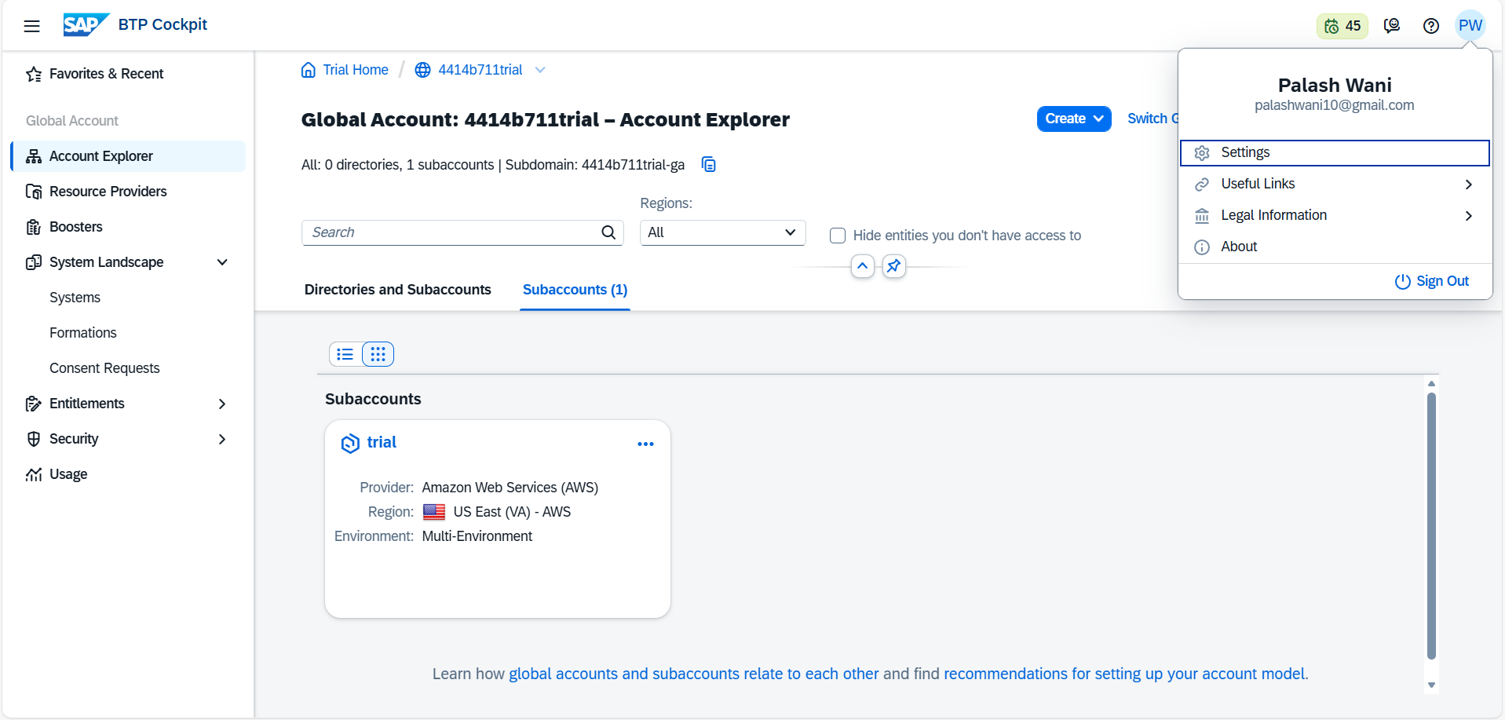

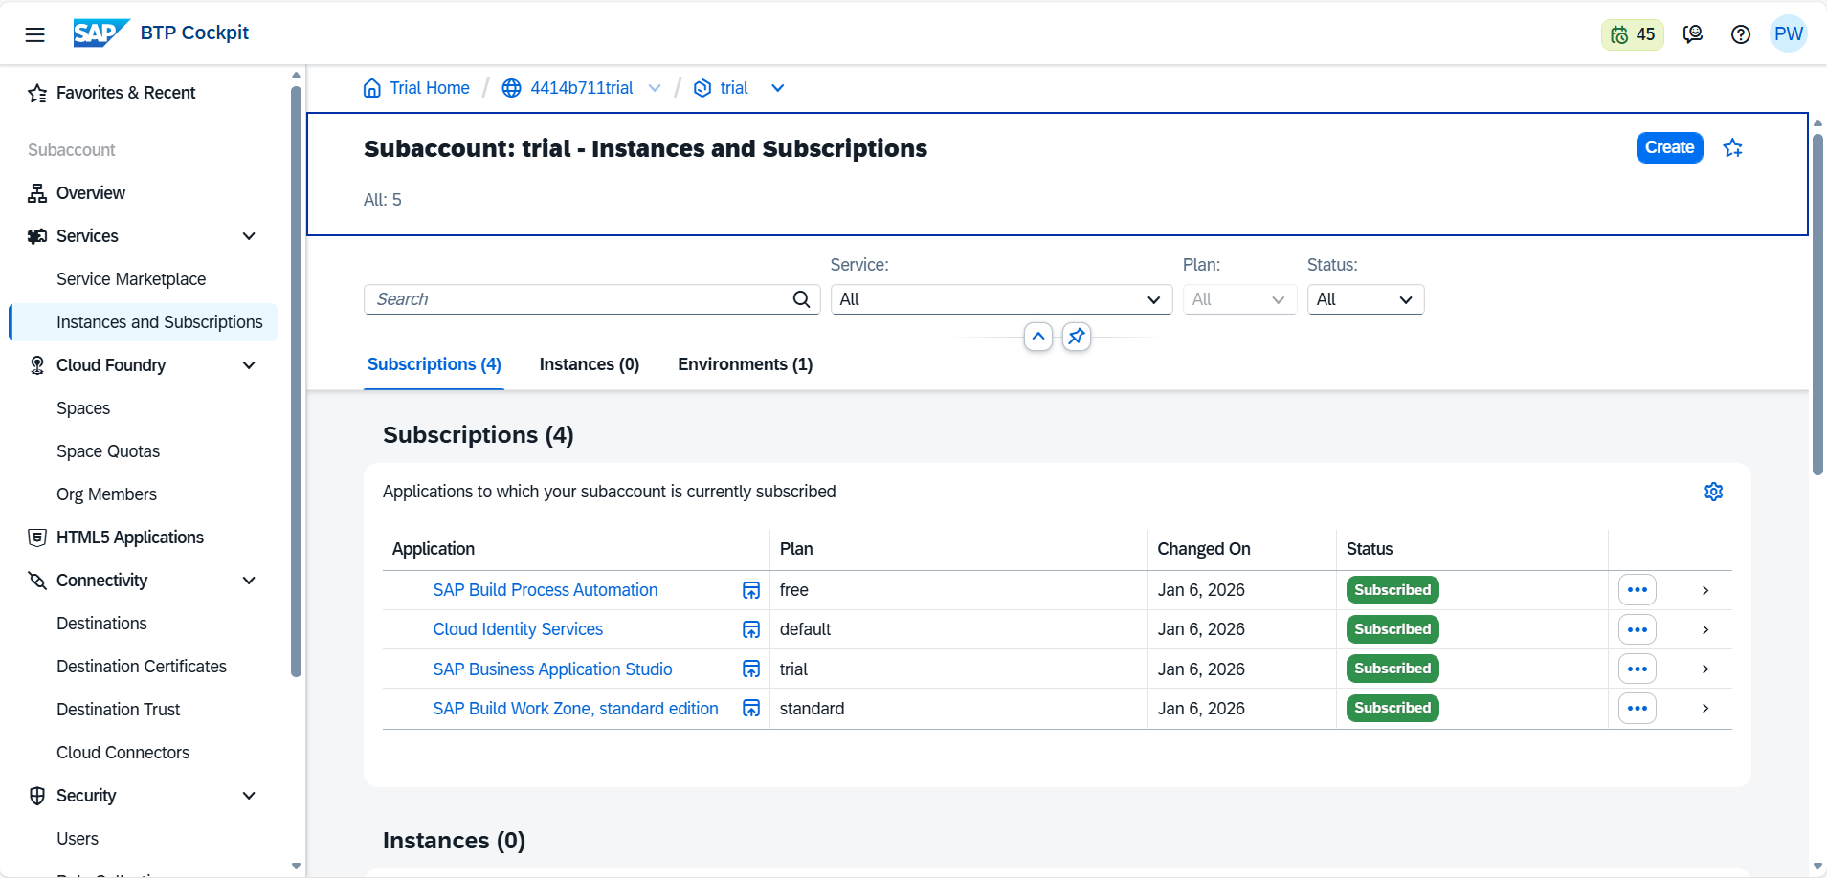

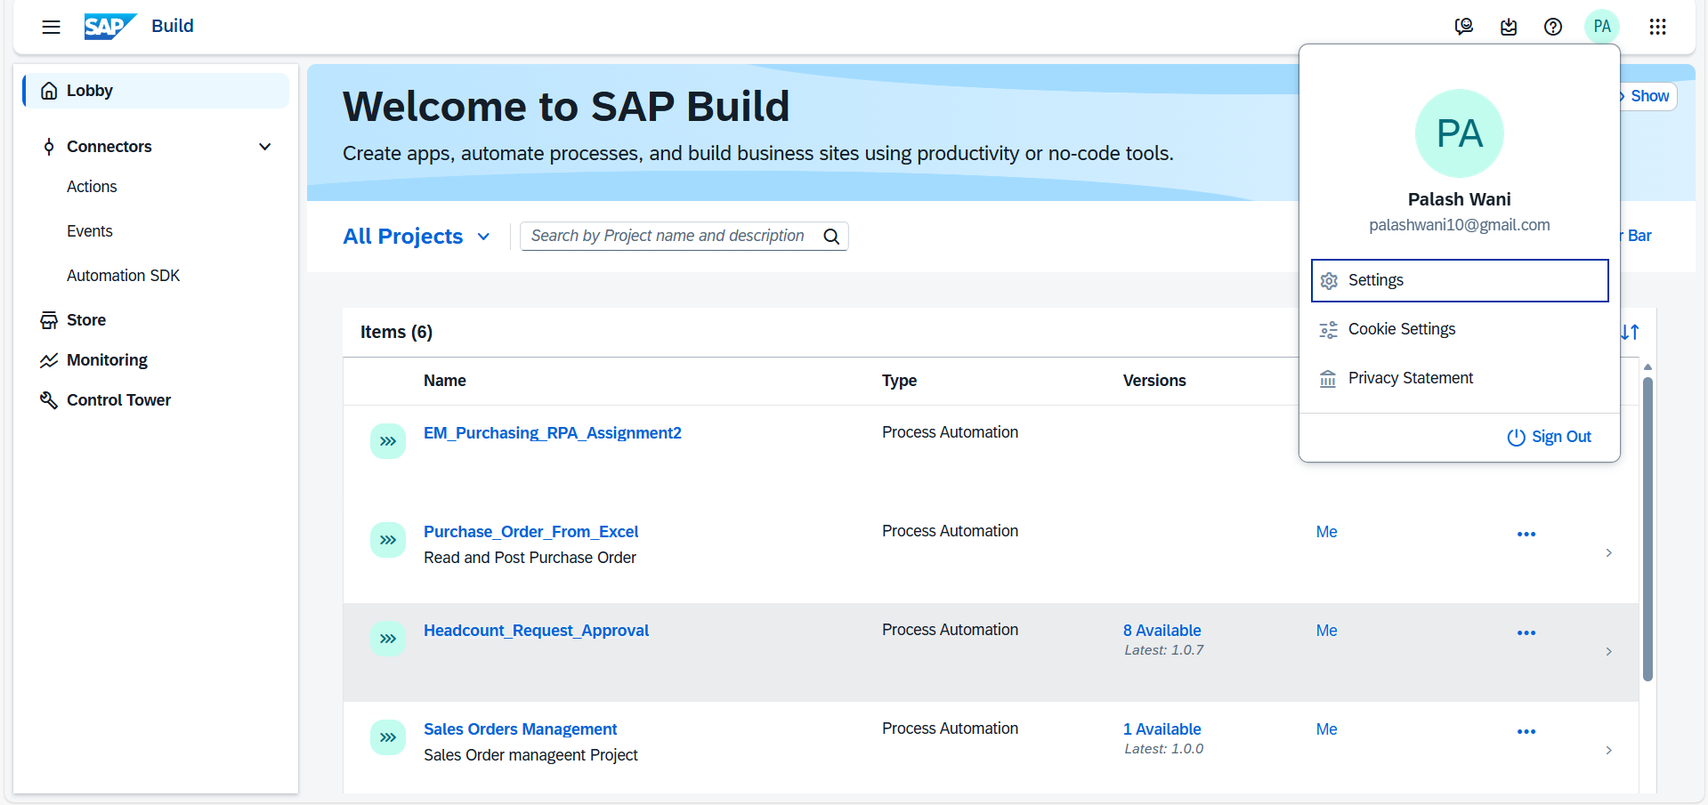

## 3.3 The solution is implemented using SAP Build Process Automation with the following components:

* Forms Editor for user input
* Workflow Editor with drag-and-drop modeling
* Excel activities for headcount validation
* Decision controls for automated rejection
* Notification steps for requester updates

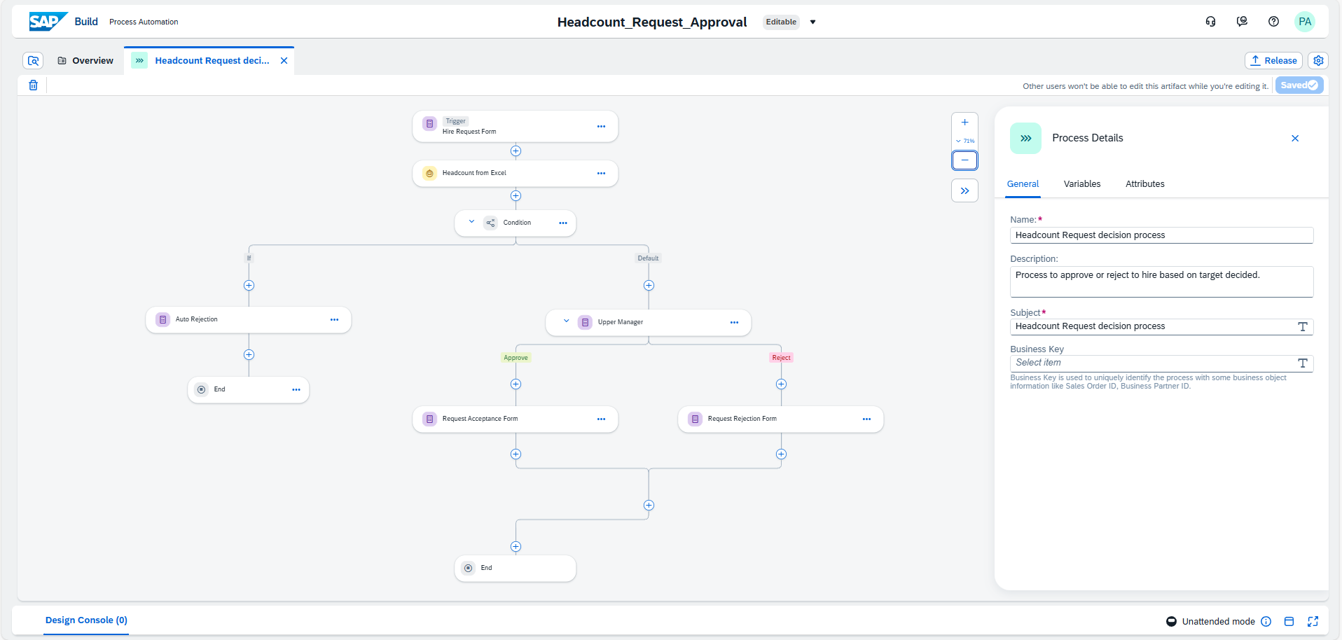

## 3.4 Headcount Request Form

A form was created using the Forms Editor to capture all required request details. Dropdown fields were used for standardized values, while free-text fields were used for justification.

Screenshot: Headcount Request Form configuration

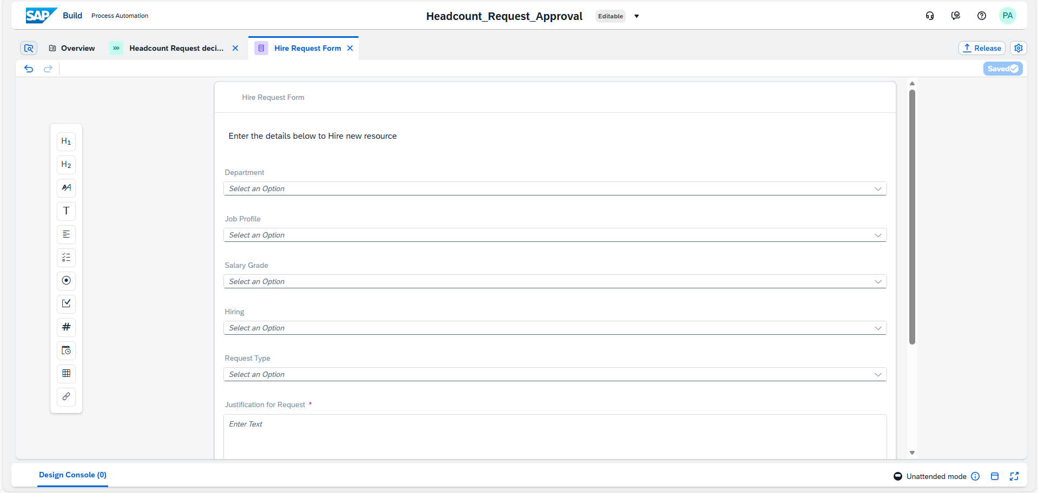

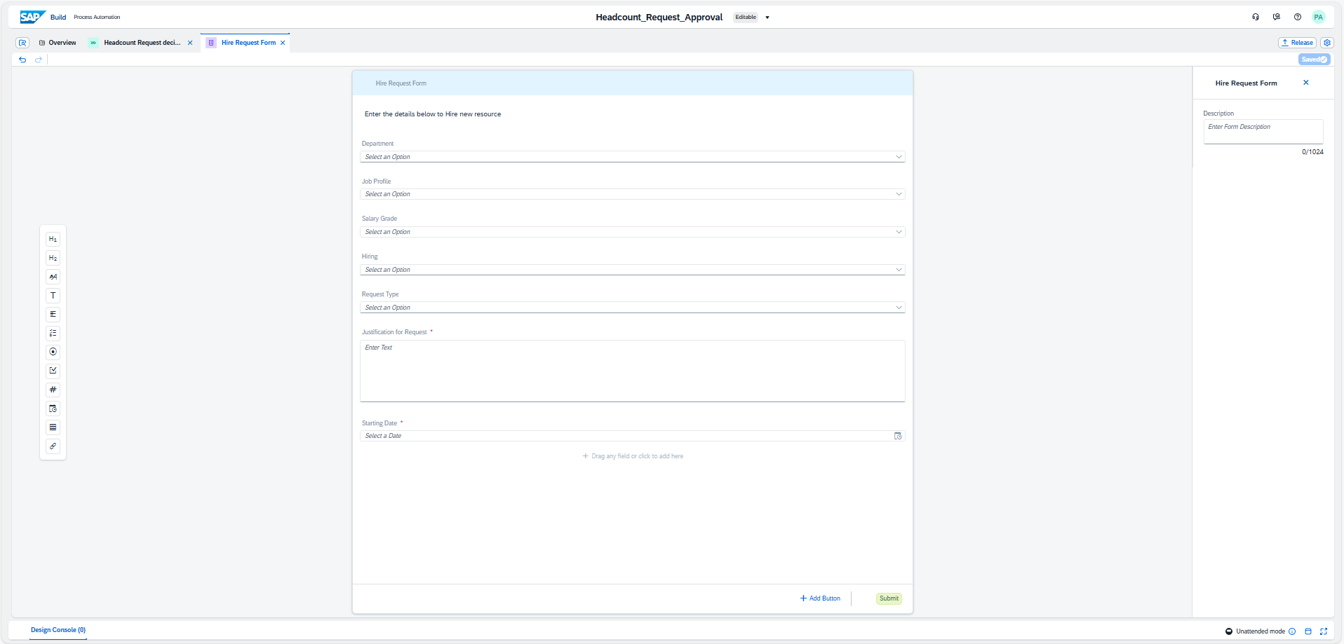

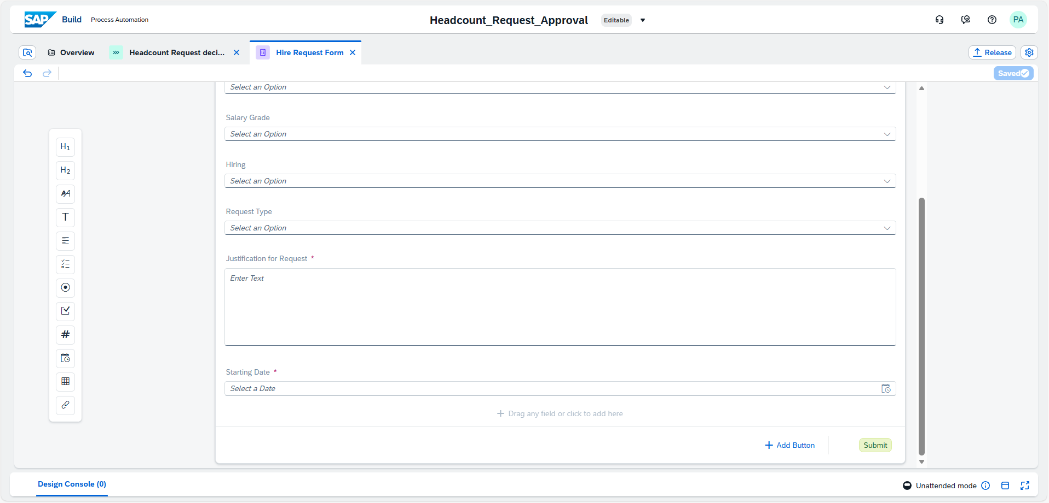

**3.3 Complete Automation Logic**

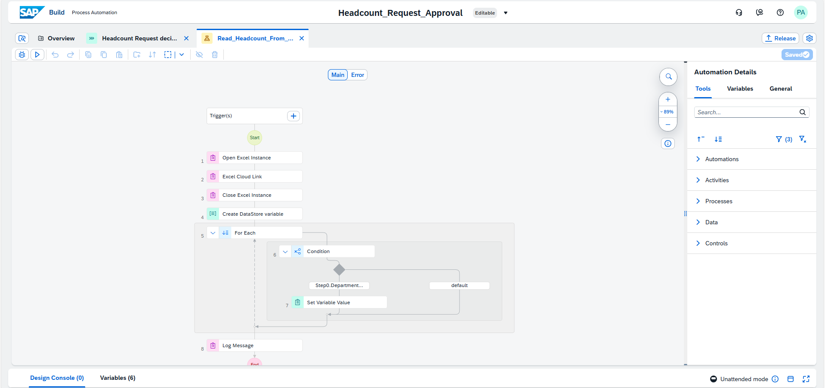

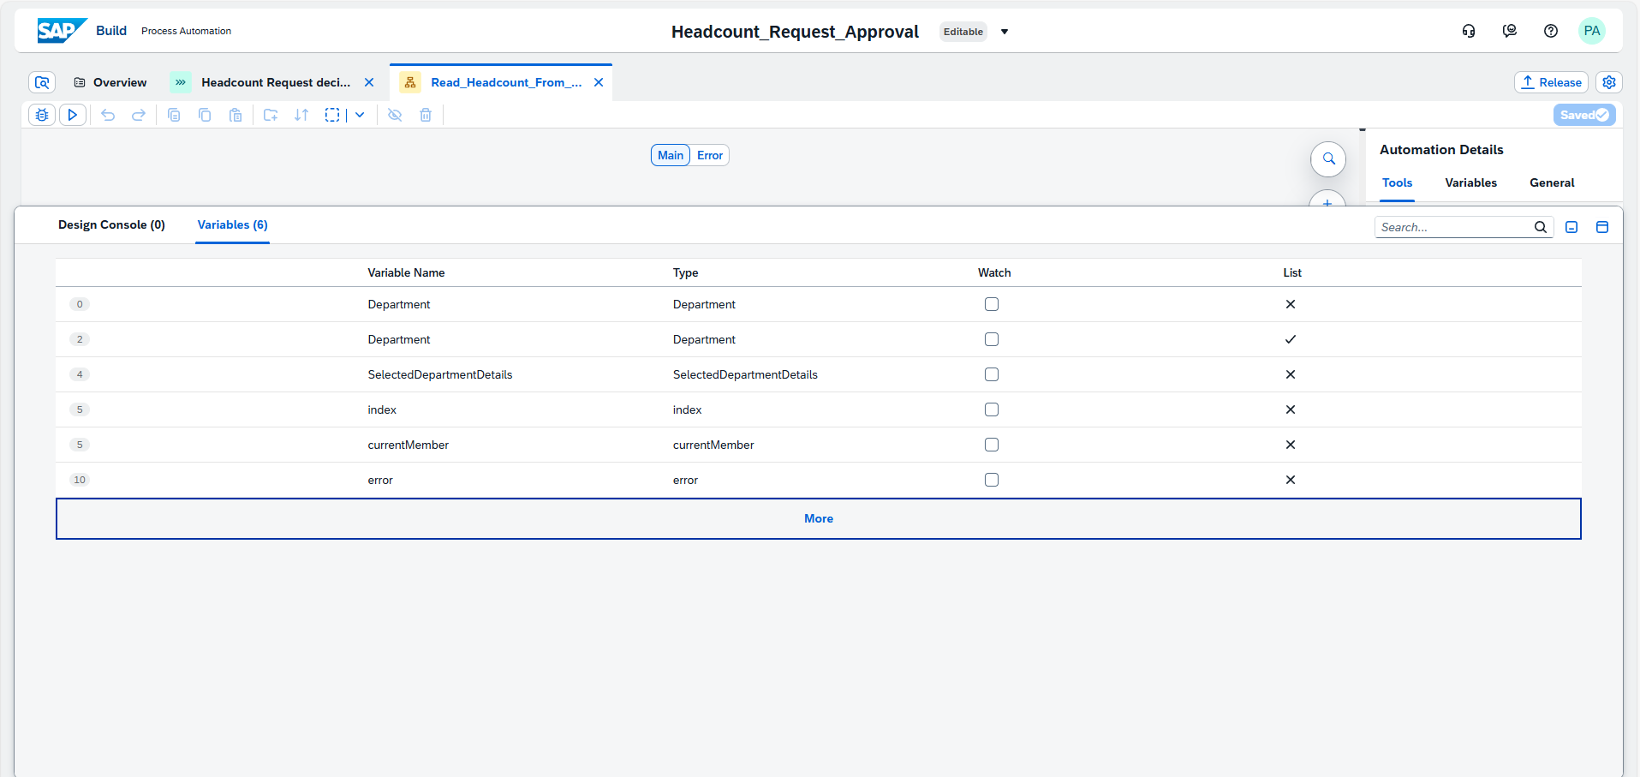

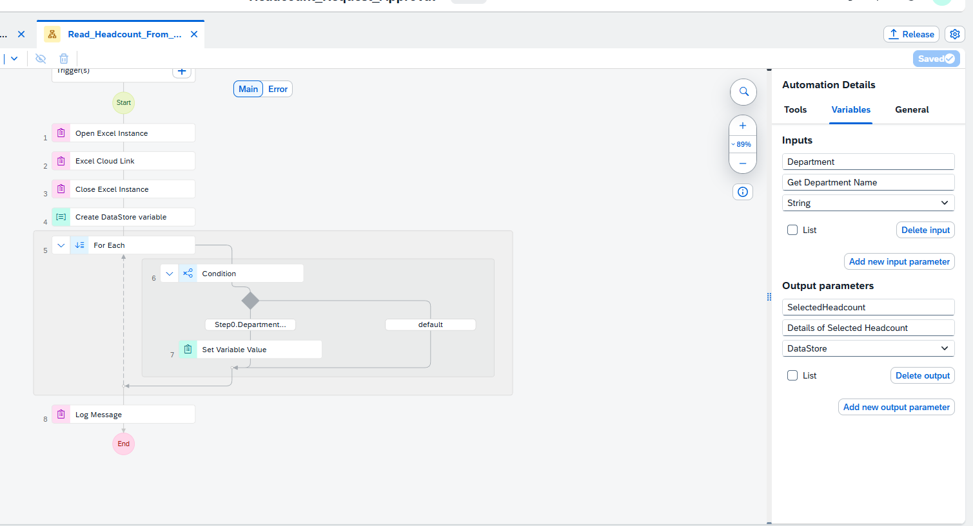

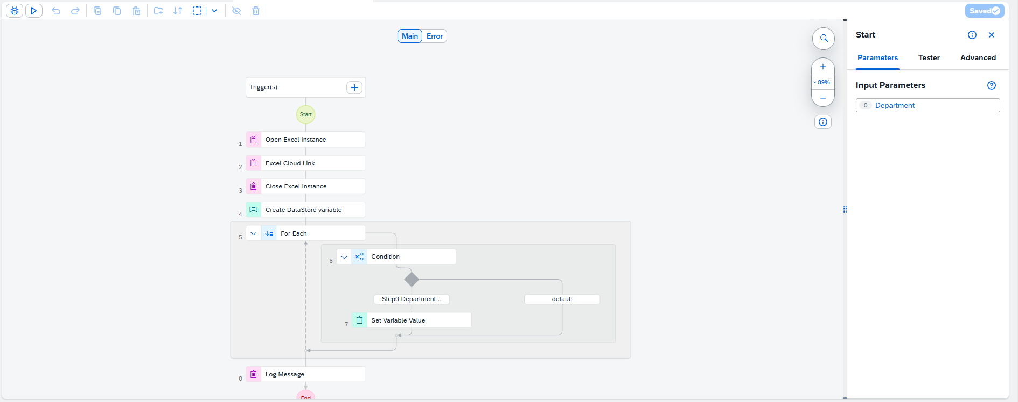

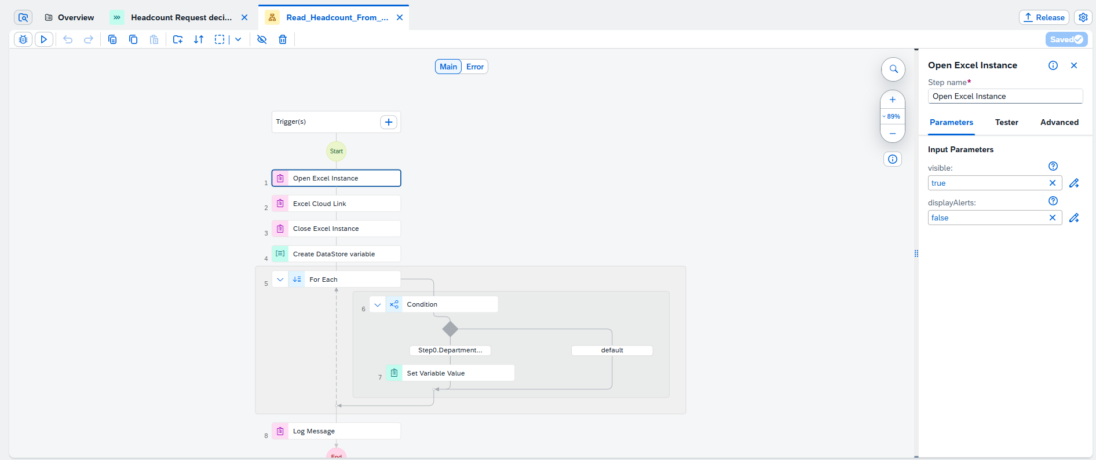

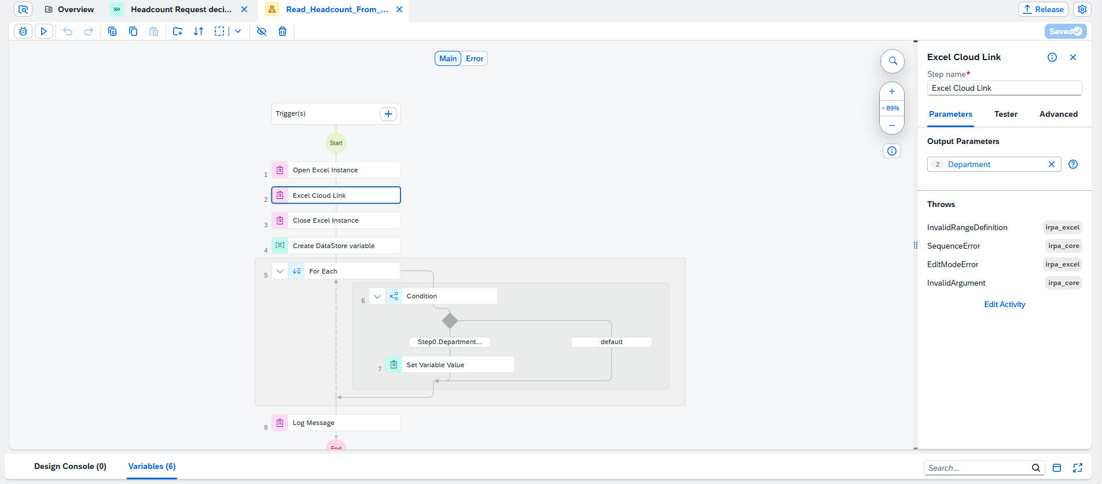

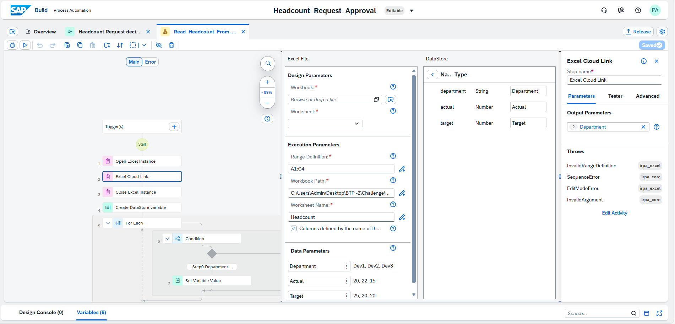

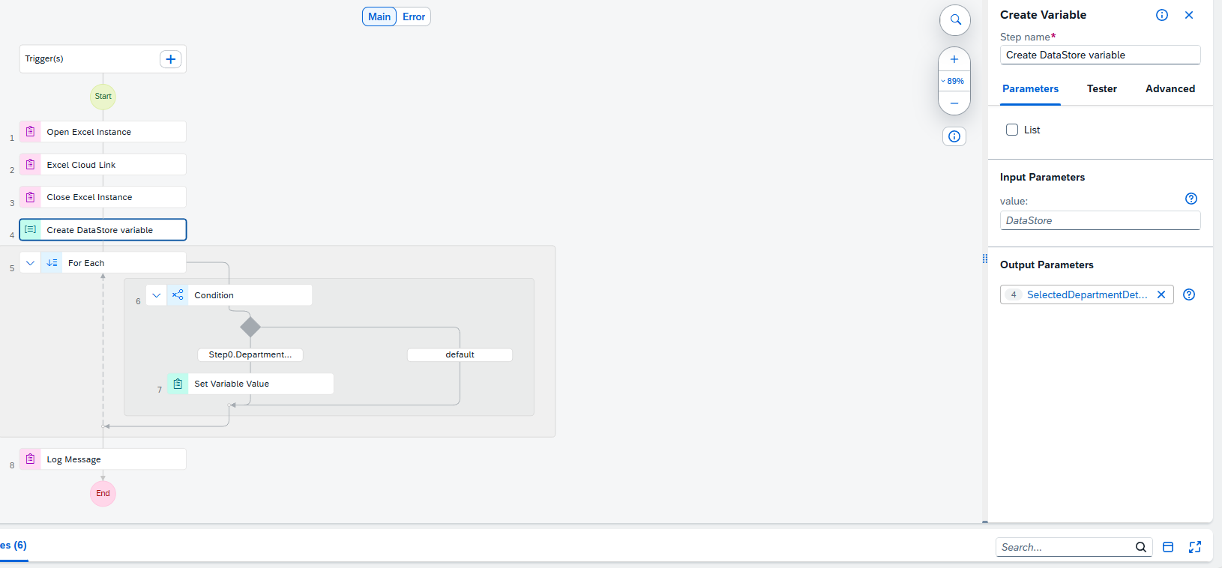

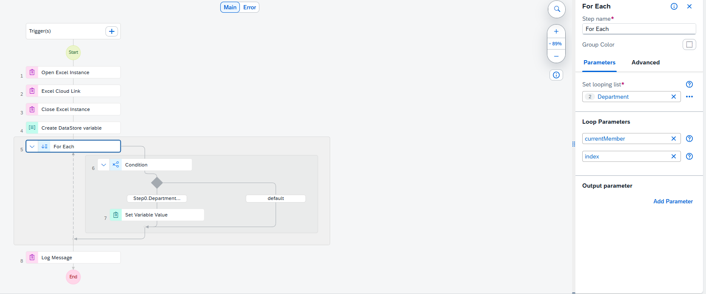

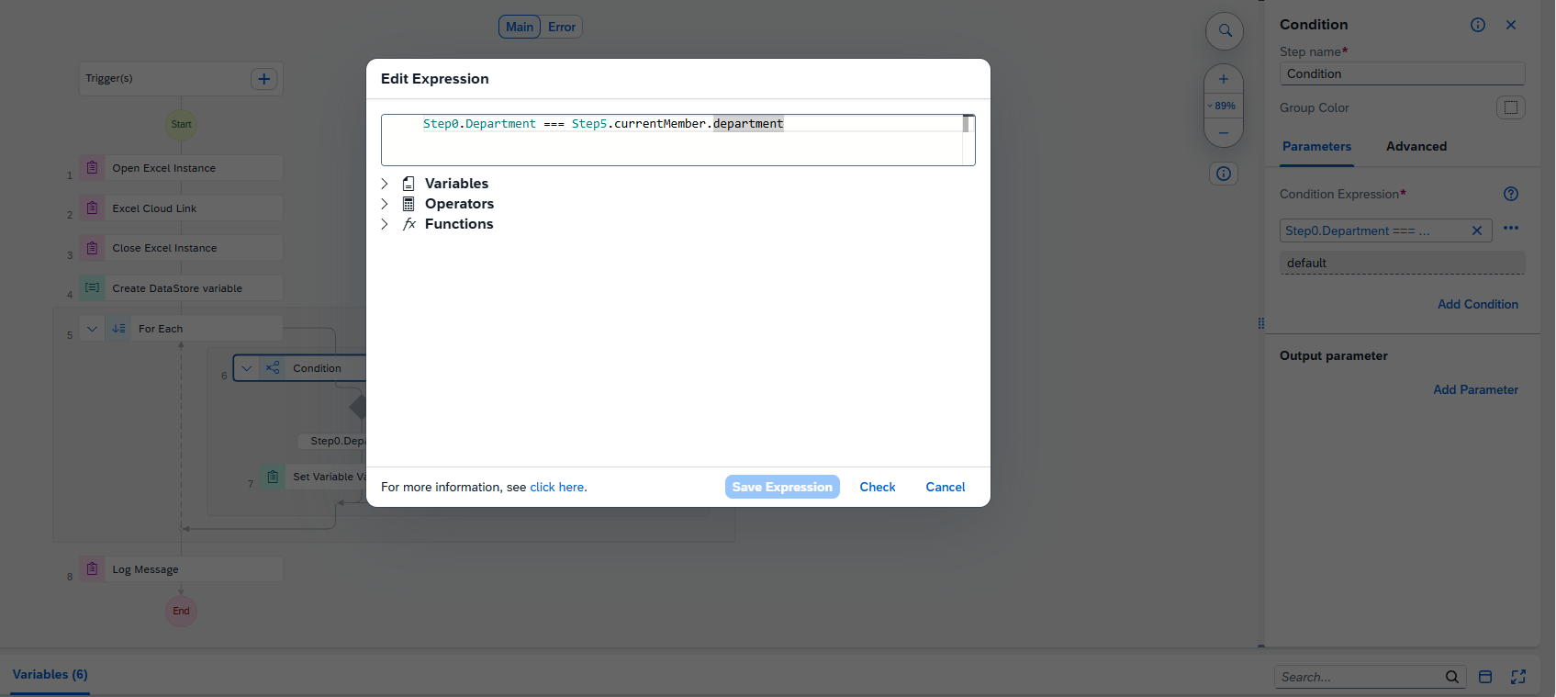

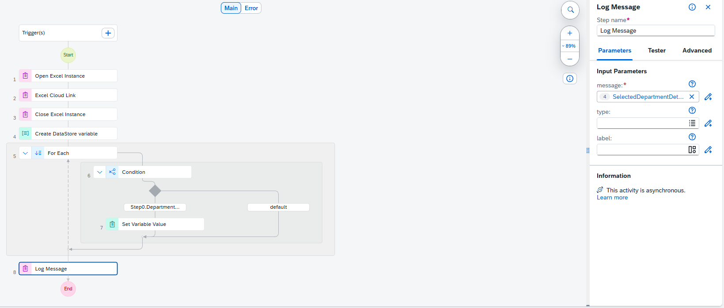

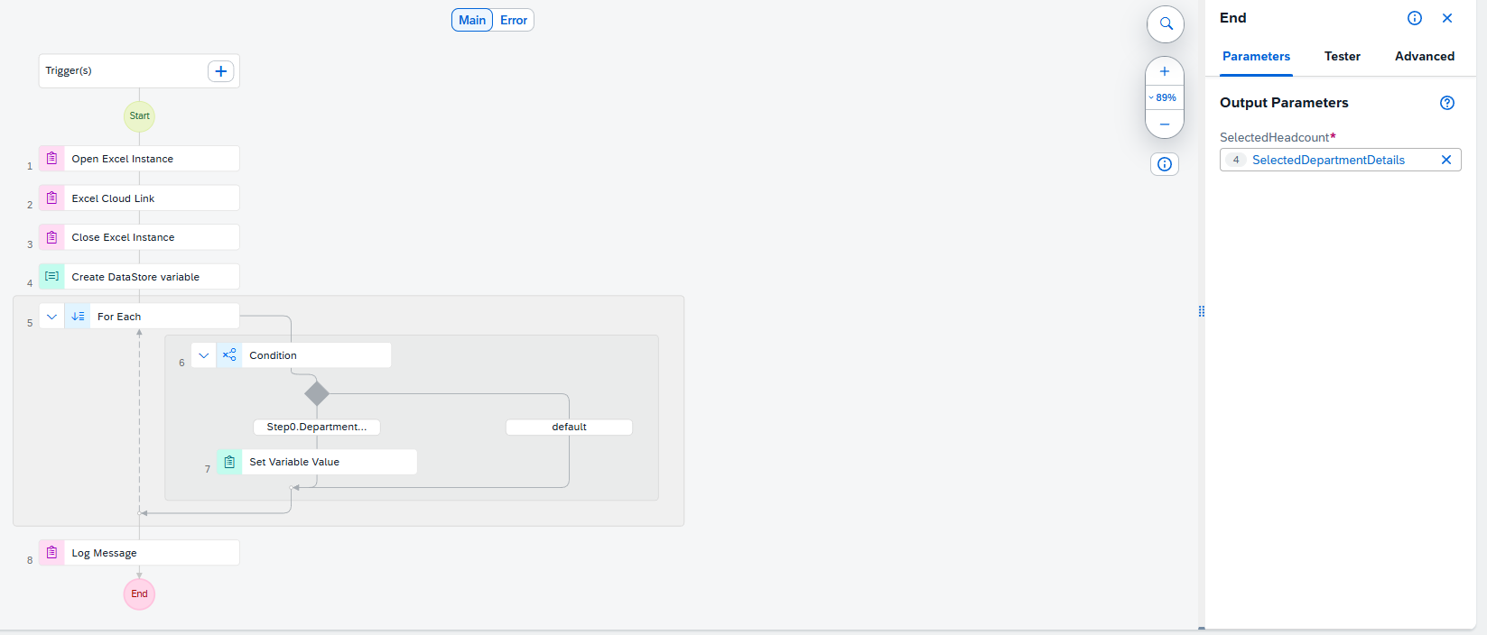

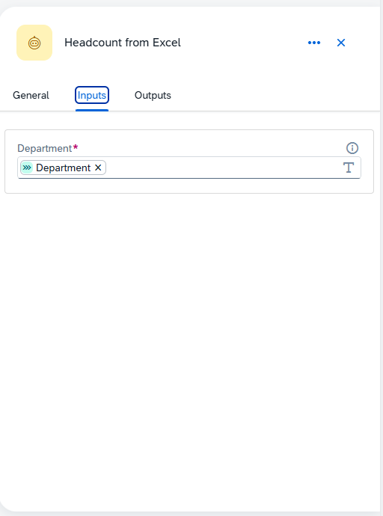 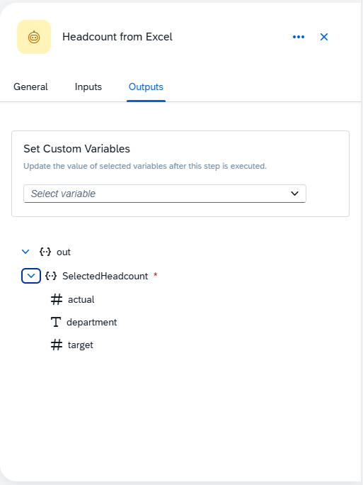

## 3.4 Automated Decision Logic

A decision control was implemented to compare the current headcount against the target headcount.

If the target headcount is lower than the current headcount, the request is automatically rejected. Otherwise, it is forwarded to upper management.

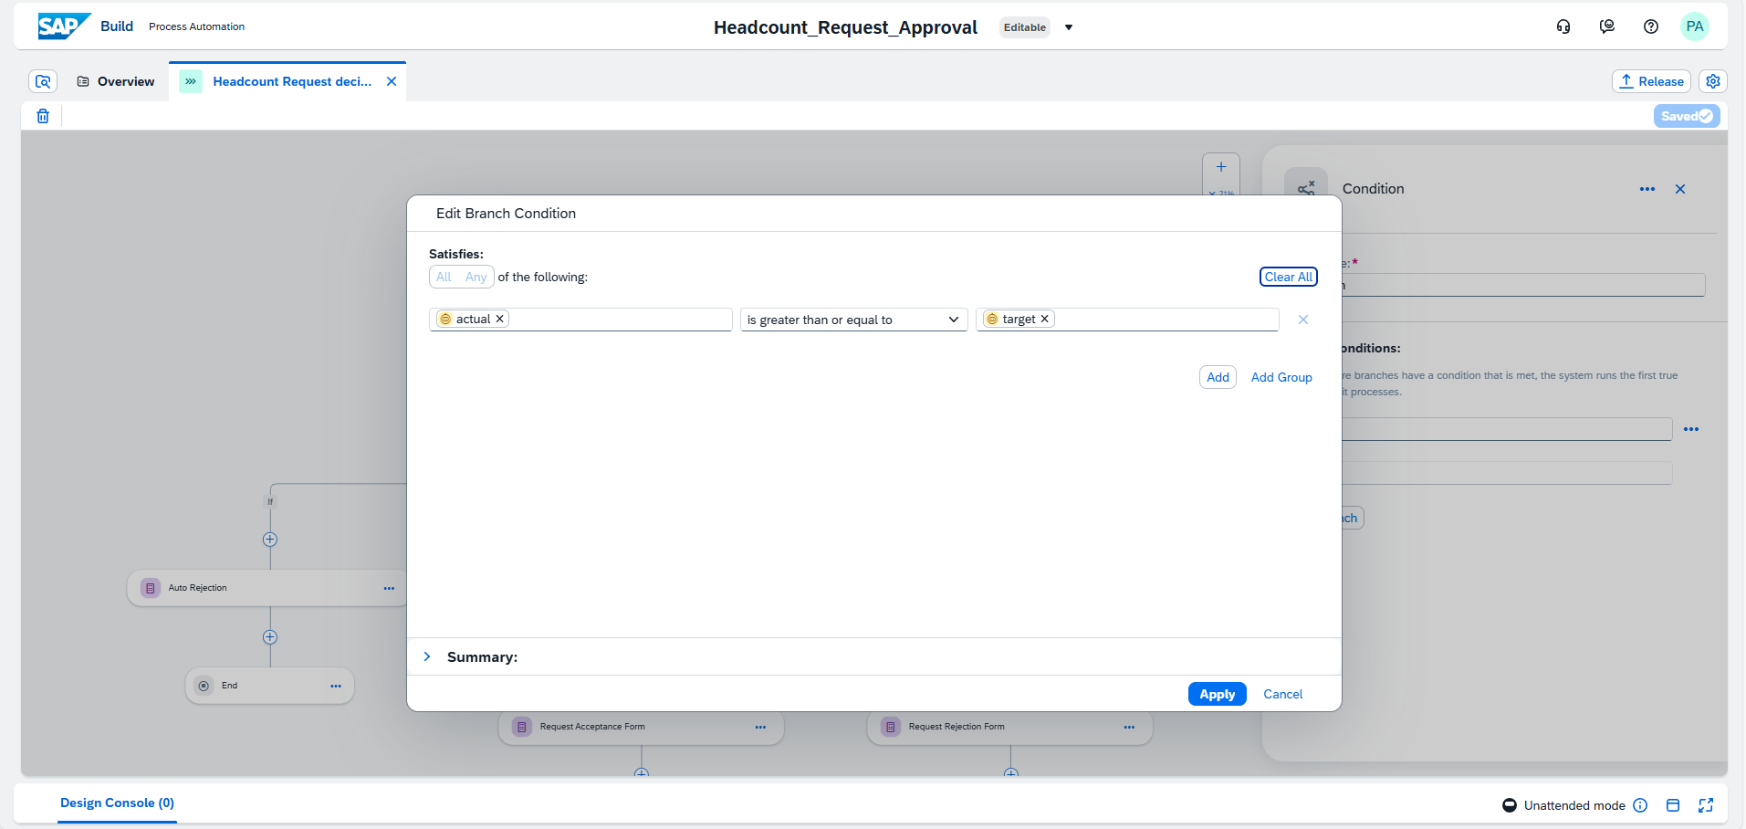

📸 Screenshot: Decision control configuration

## 3.5 Approval and Notification

Once validated, the request is sent to upper management for approval. Based on the decision, the requester receives an automated notification.

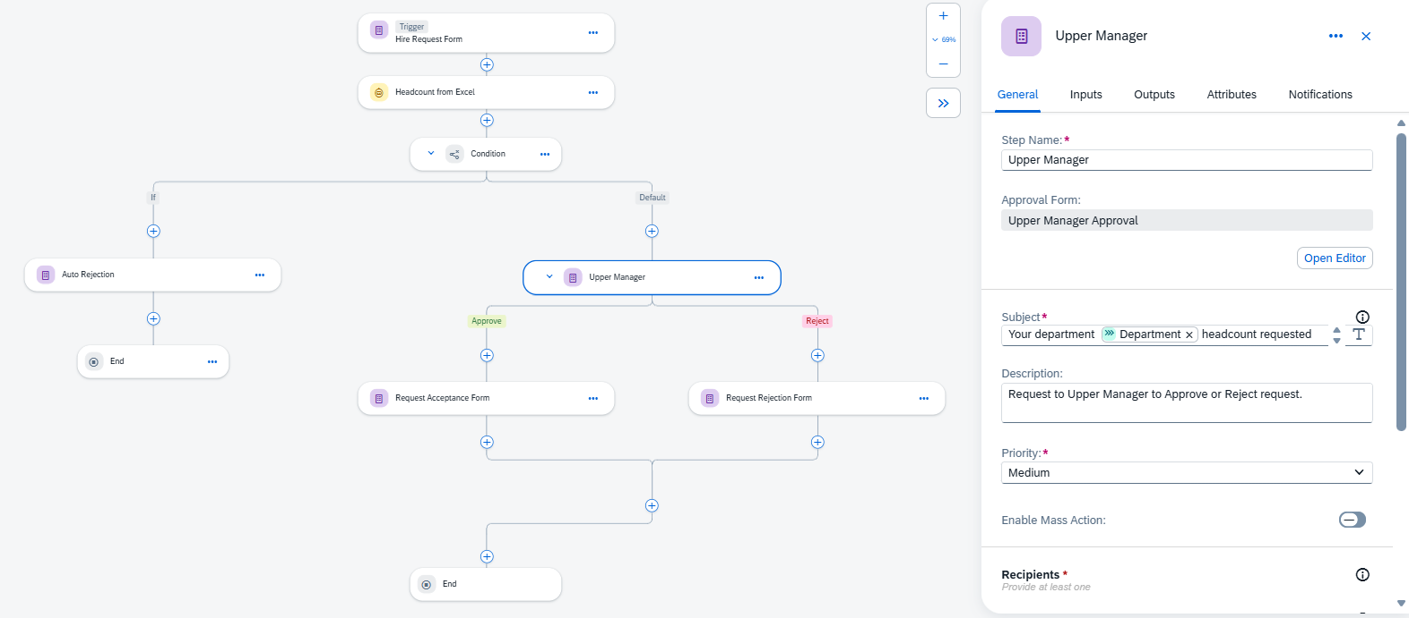

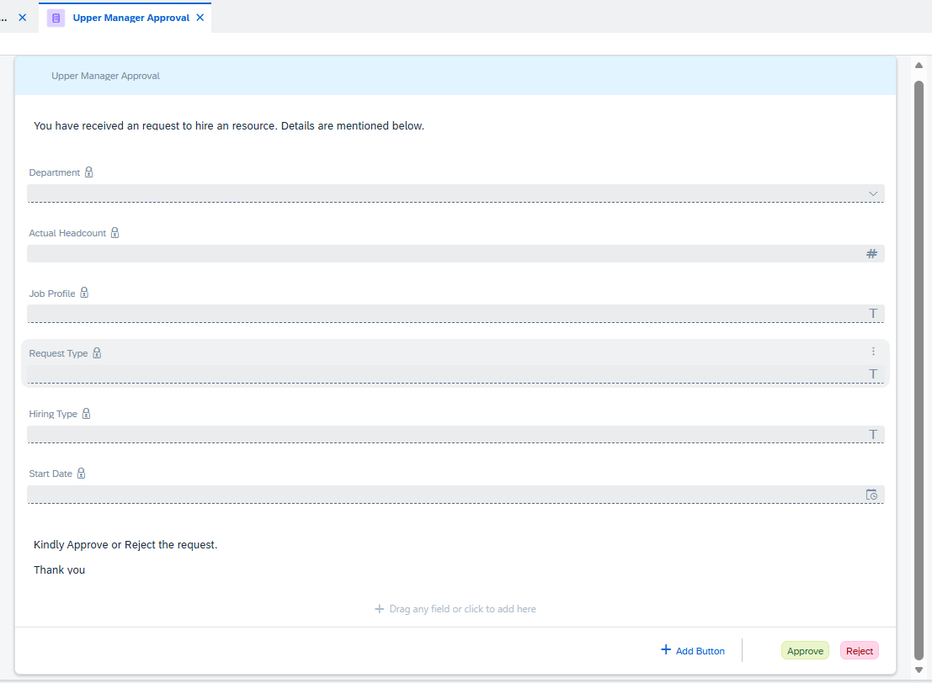

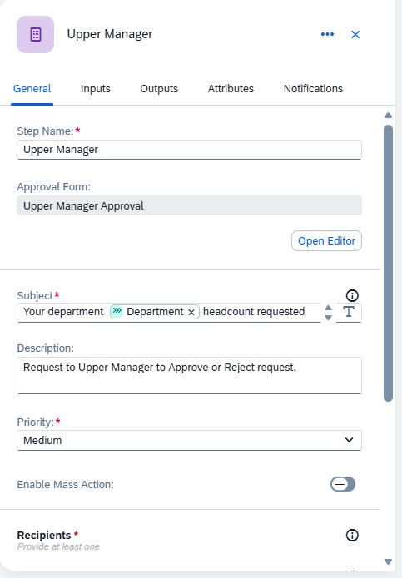 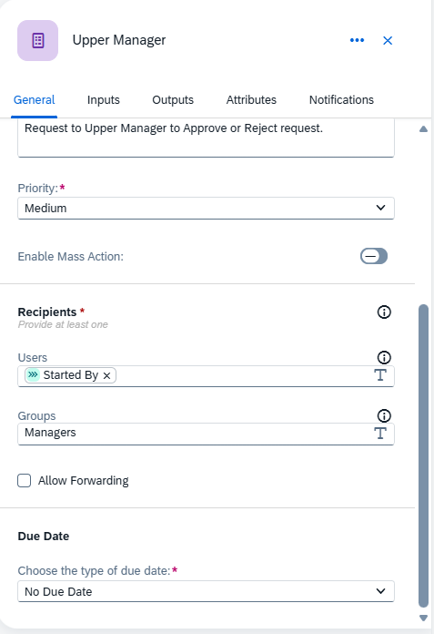

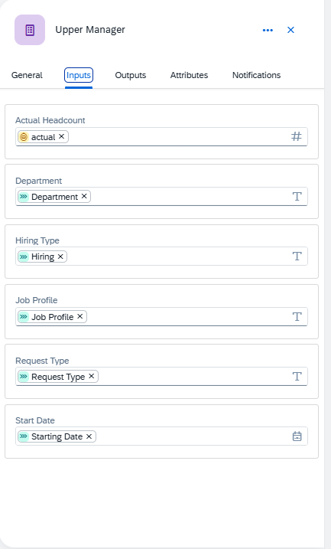

Screenshot: Approval task and notification setup

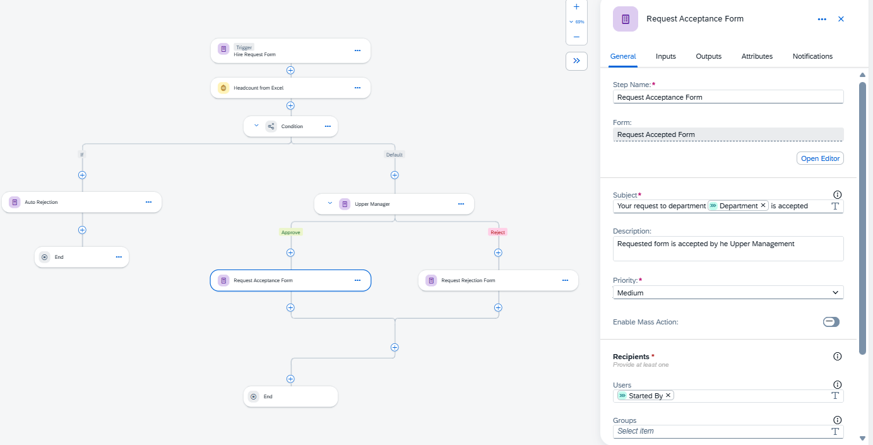

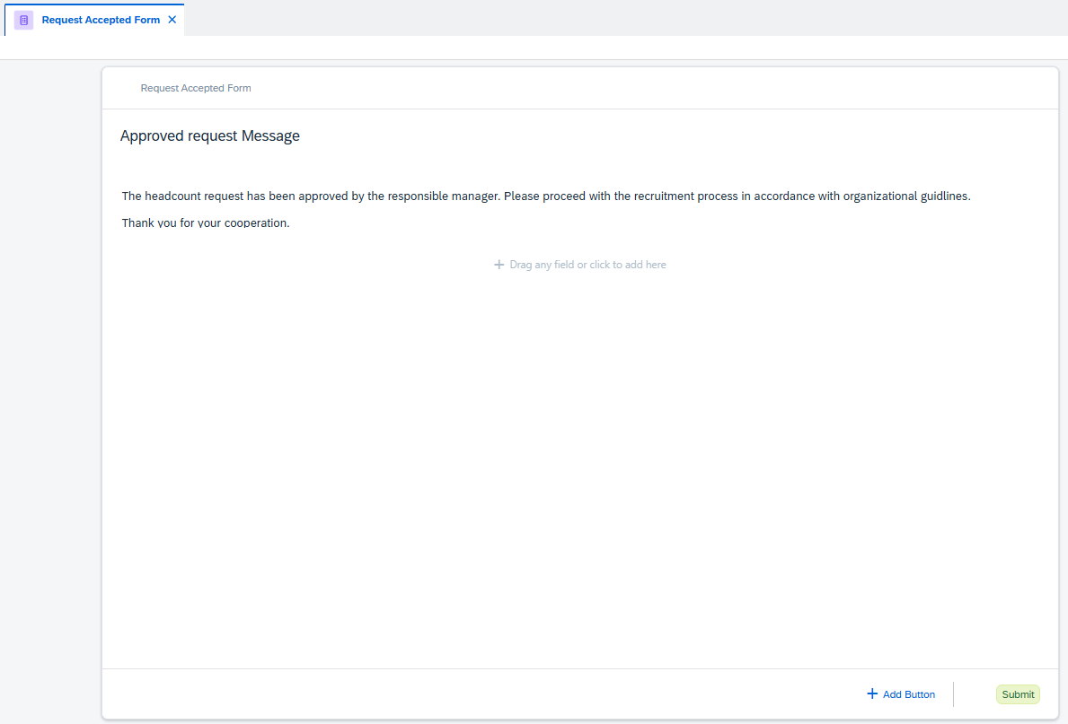

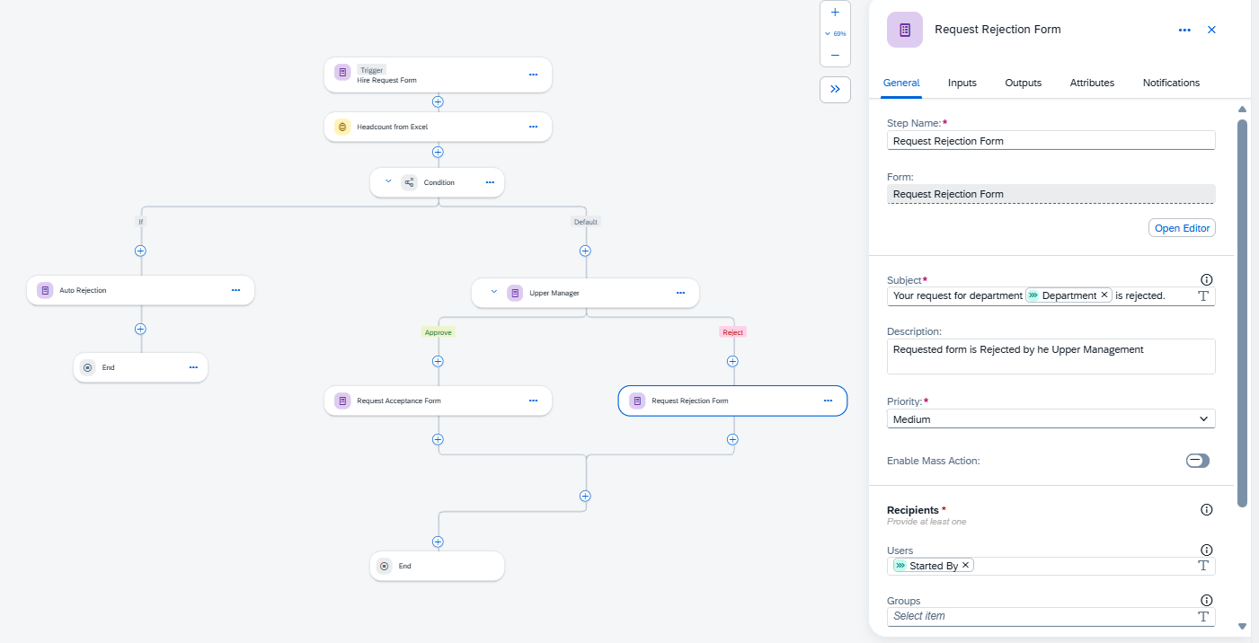

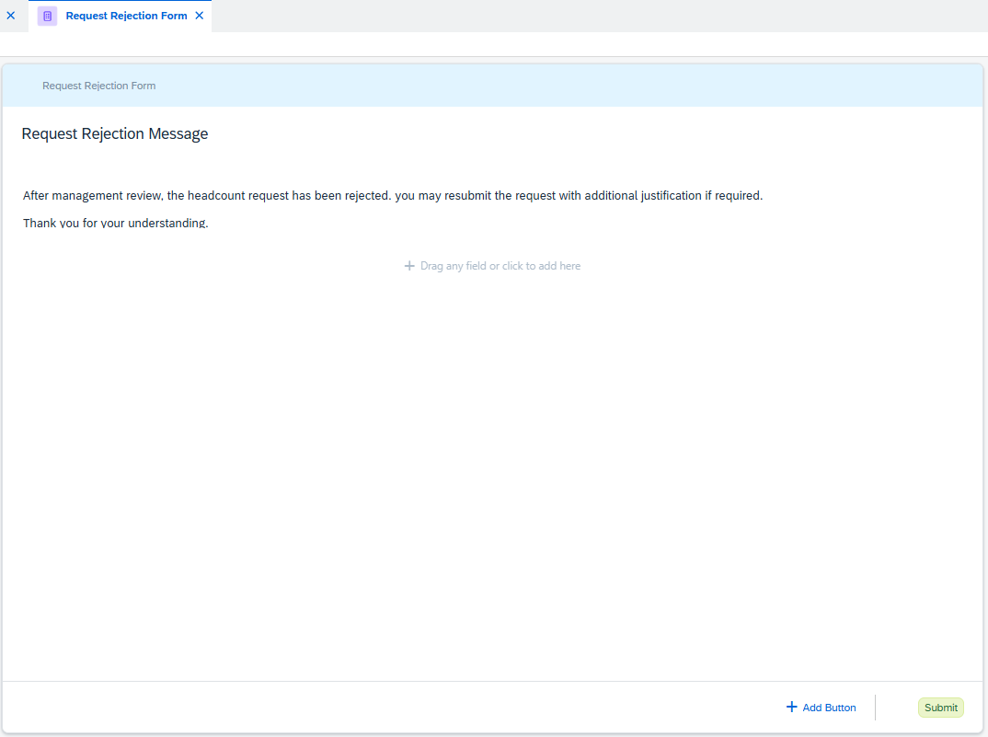

# 4. Automatic Rejection Handling

Requests that fail the headcount validation rule are automatically rejected without manual intervention. This ensures strict adherence to headcount targets and reduces unnecessary approval workload.

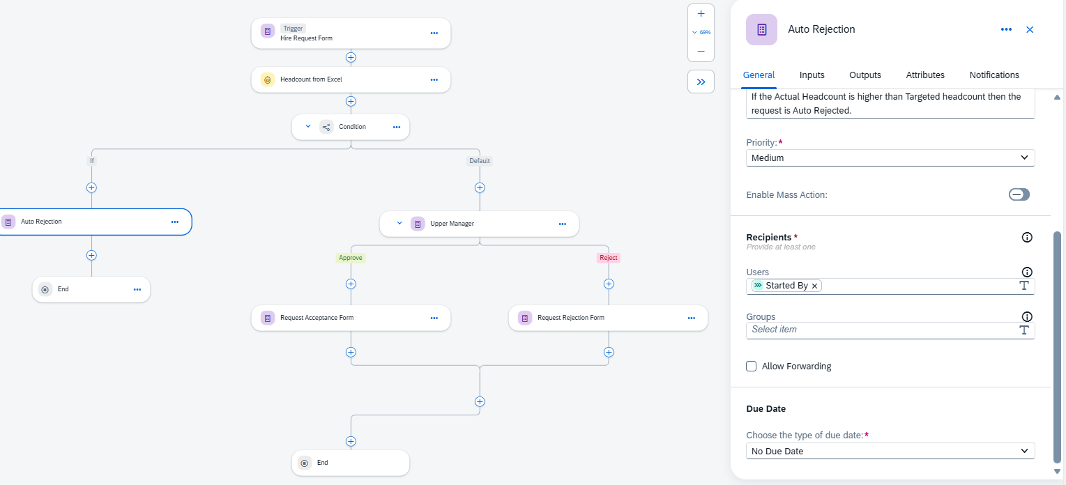

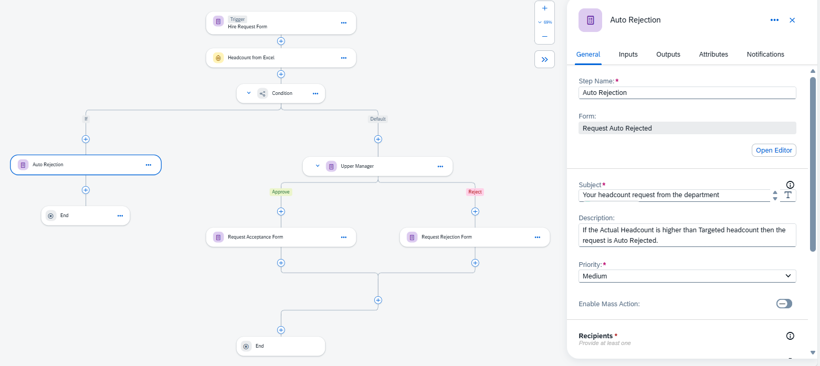

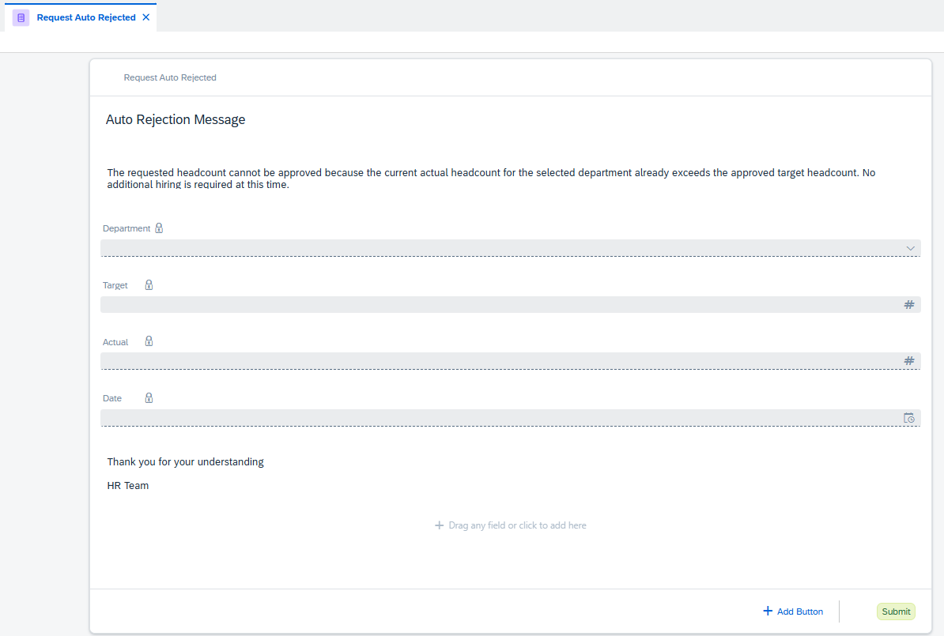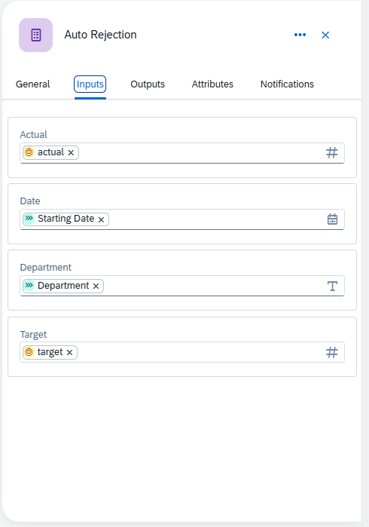

# 5. Conclusion

This implementation demonstrates a real-world use case of SAP Build Process Automation to handle headcount approvals efficiently. The solution ensures transparency, automation, and compliance while reducing manual effort.

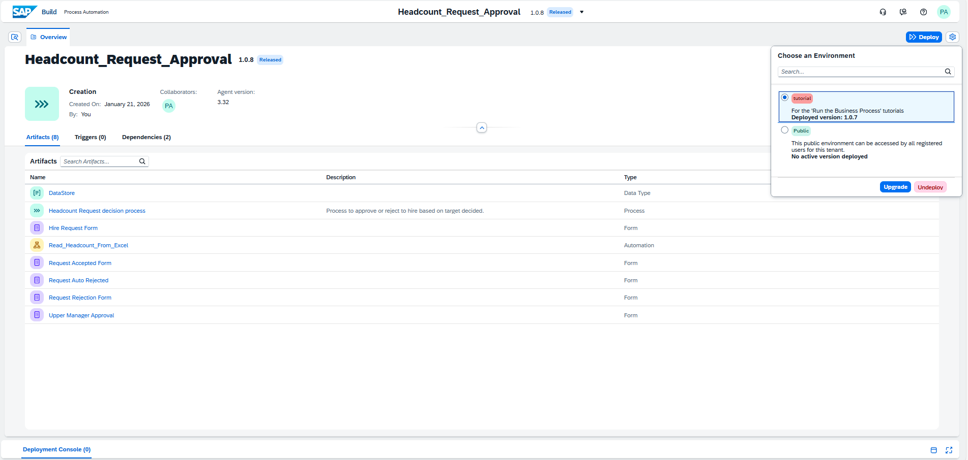

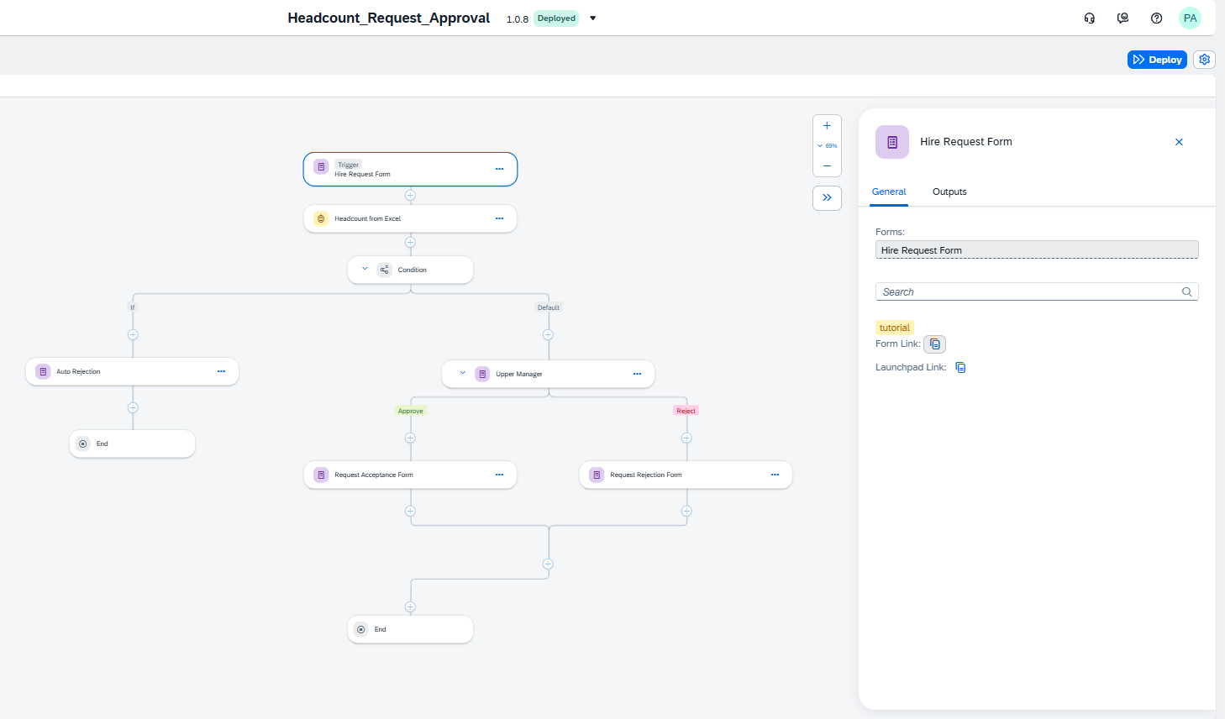

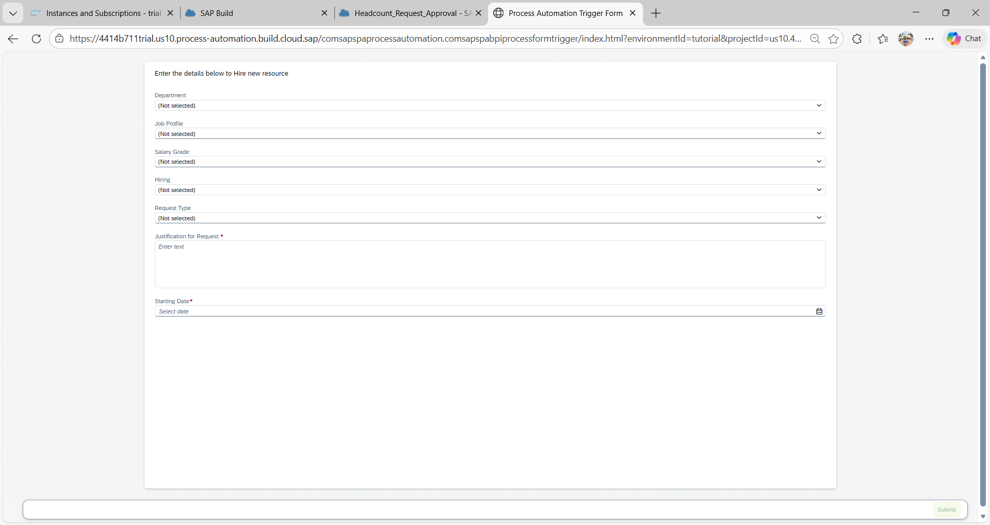

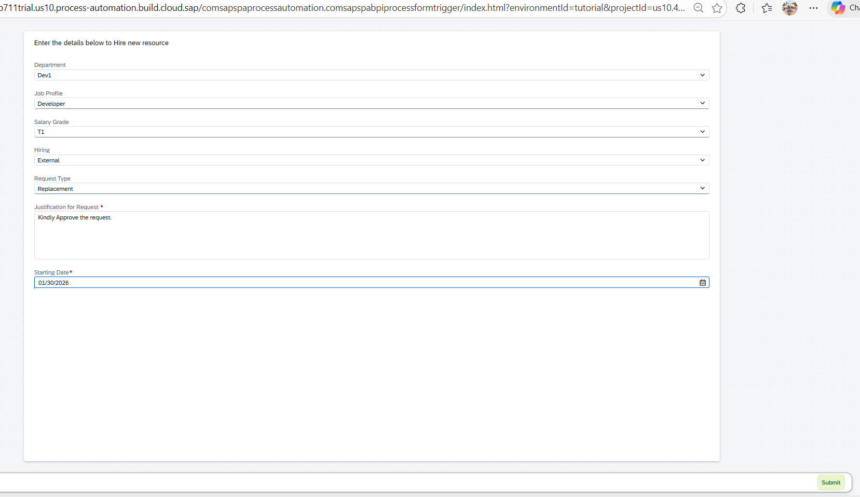

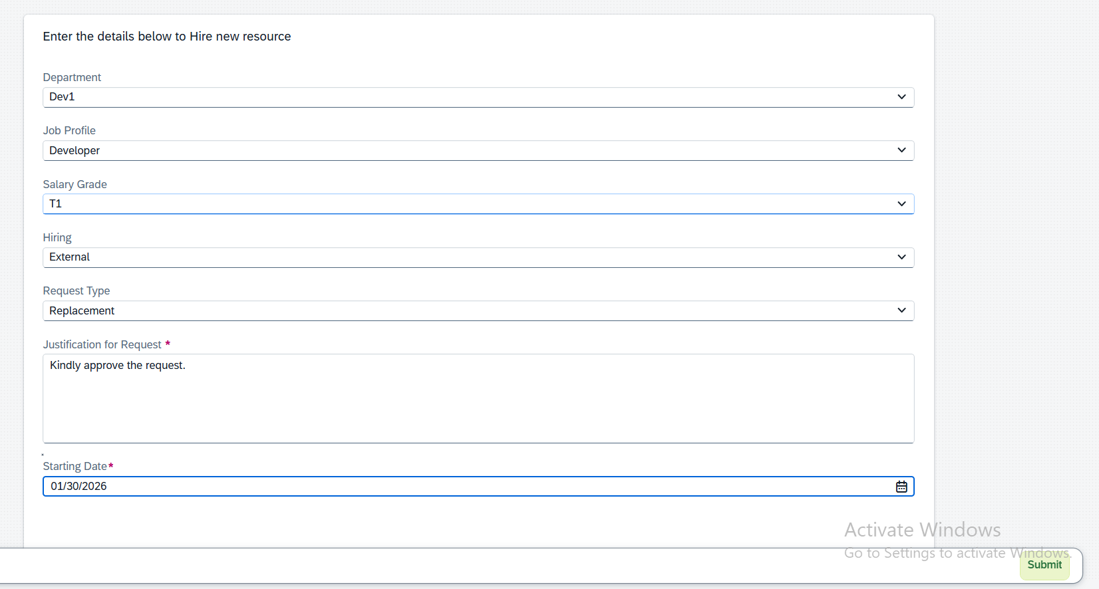

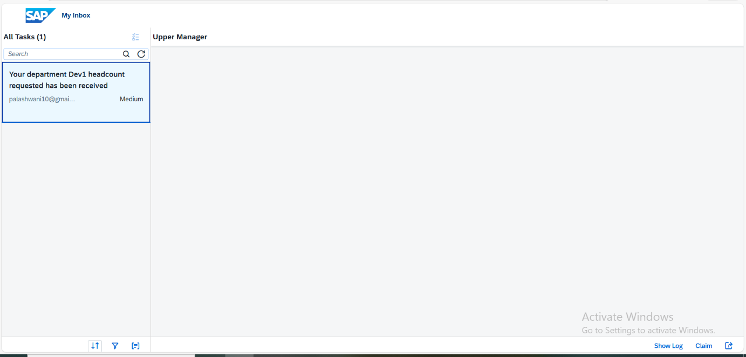

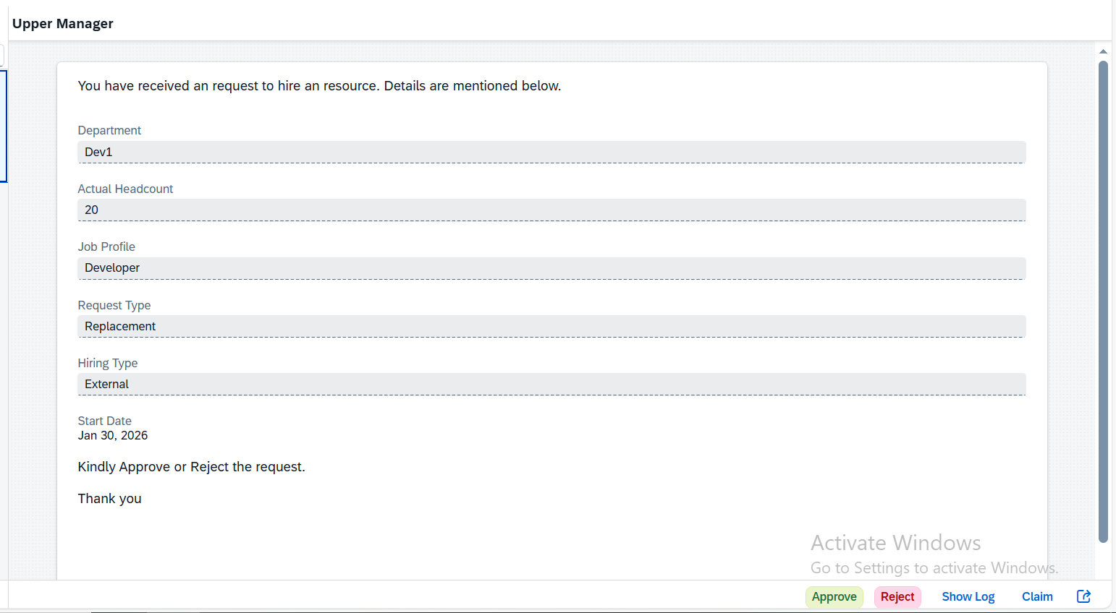

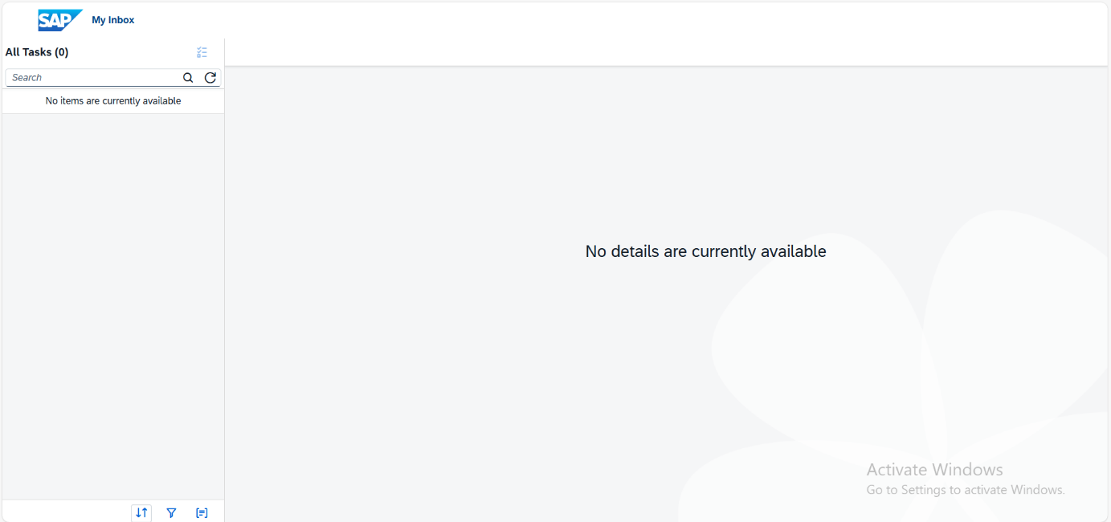

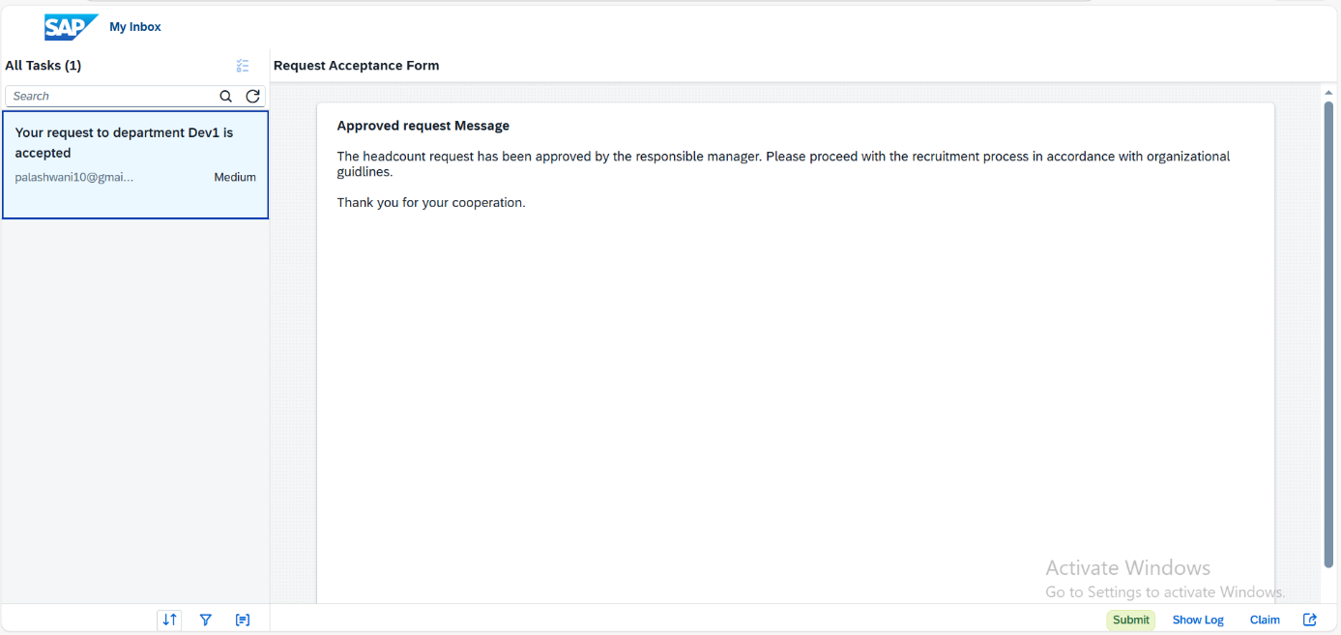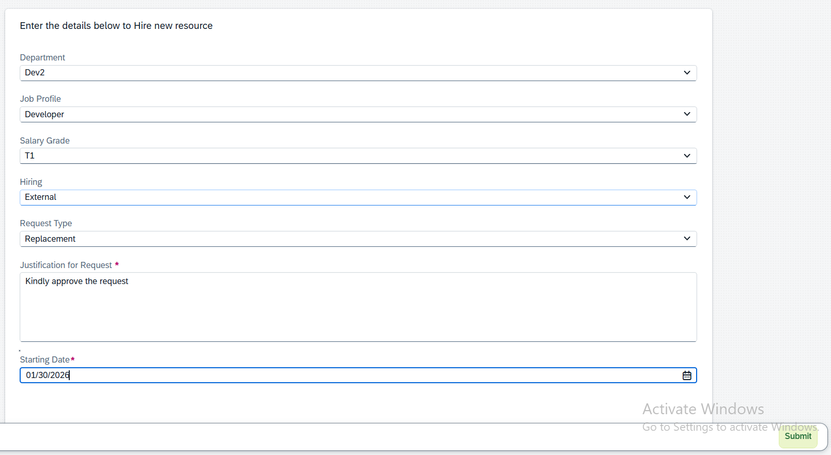 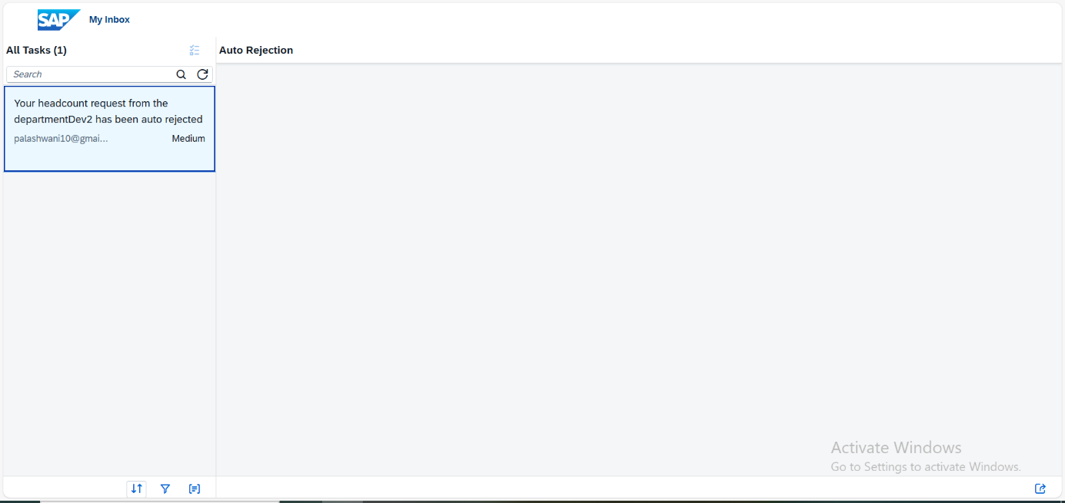

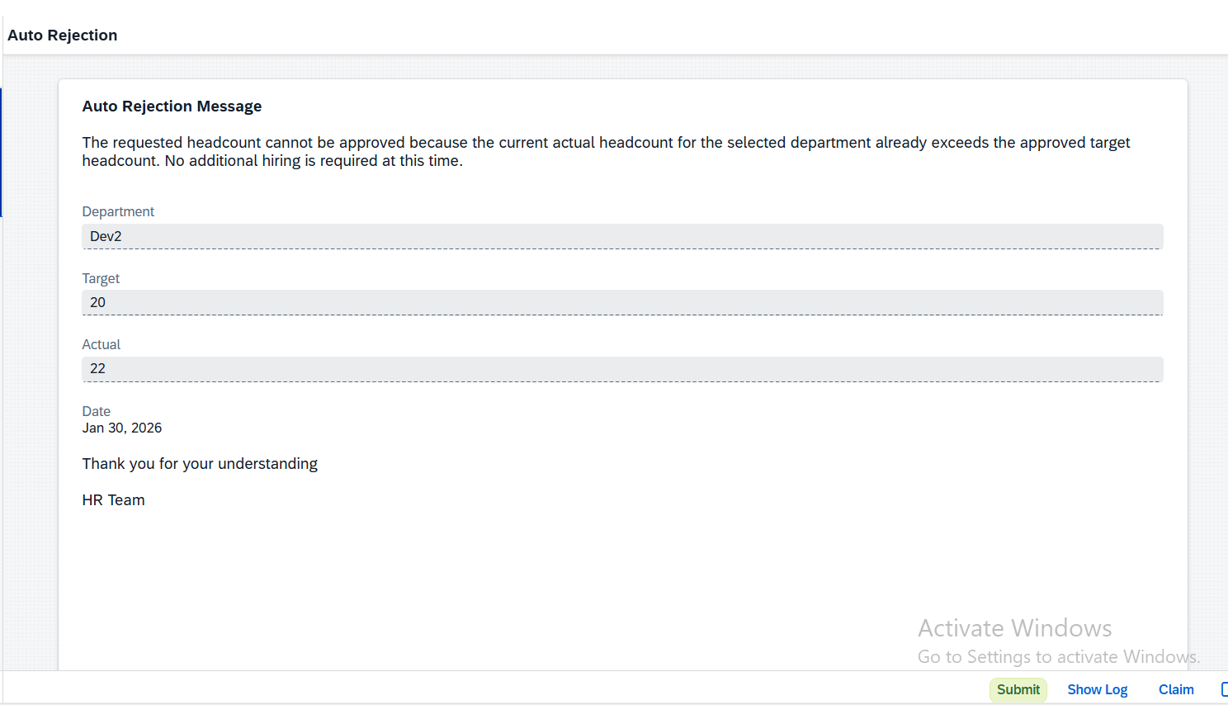

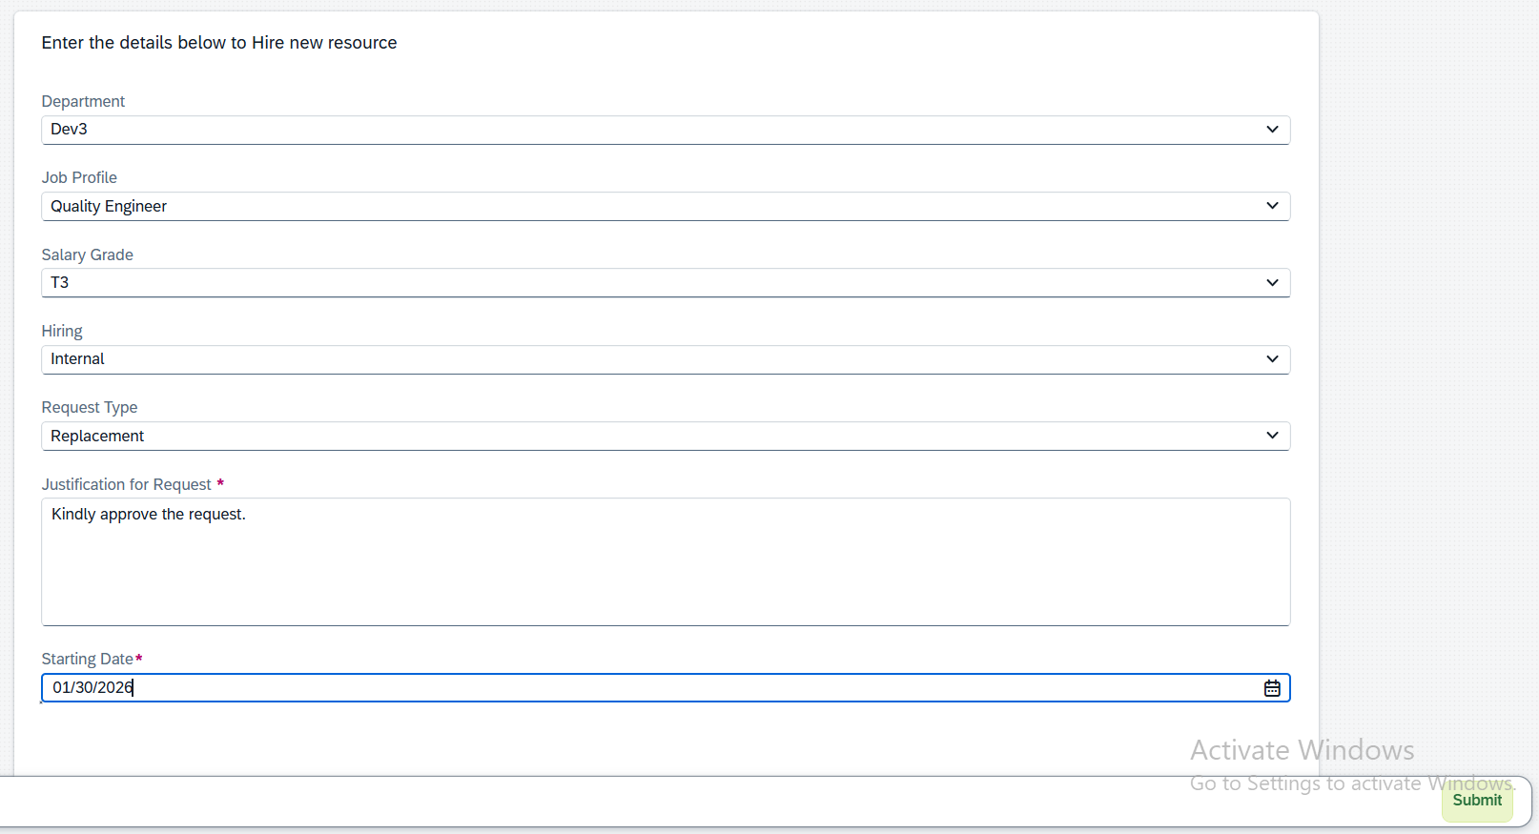

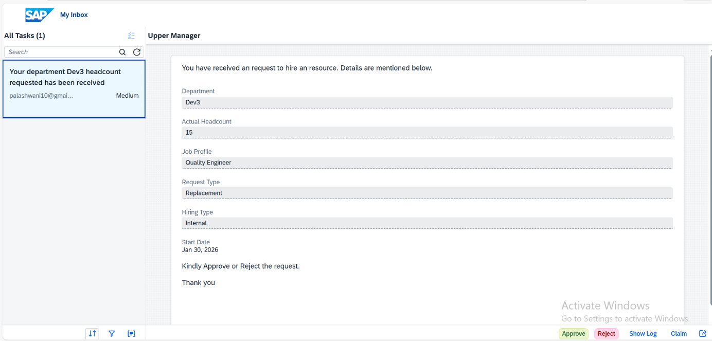

. 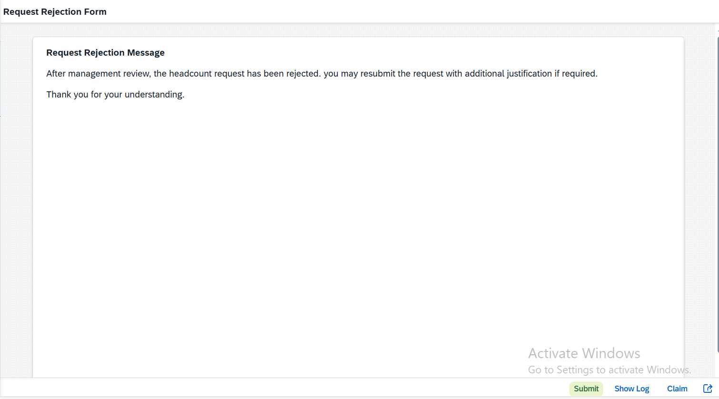

# 6. GitHub Documentation Note

Due to platform limitations, SAP BTP workflows and forms cannot be executed on GitHub. This repository therefore contains this documentation and screenshots to demonstrate the design and implementation approach.